

**Research**

**Project**

For Association For Transparency,

Governance & Public Grievances

**Part I**

Make in India

**Part II**

Petroleum products under GST



**Best Modi Govt.**

**Policy Since 2014**

“Make in India”

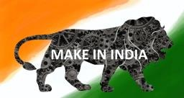

**Make In India: A Lion Step**

* Make in India, is a propaganda initiated for the sole purpose of inviting various commercial sectors from all around the world, to engineer their products in India and sell them anywhere they wish. The crusade had instigated on 25th September 2014, and since then has emerged as one of the grandest triumphs of the Indian economy.
* According to my point of view the best Modi-govt scheme or initiative which contributed to common people overall growth is "Make in India" initiative. I will describe my view in 4 points.

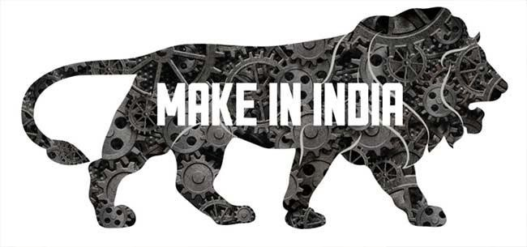

# 1. Employment Generation

* Simple economics, if companies produce in India they have to hire labor and it will generate a good amount of jobs specifically in manufacturing sector.
* It is the main purposes of Make in India crusade is to provide job opportunities for as many citizens of India as possible. It has targeted the young generation of the country as its prime beneficiary. The investments in the targeted sectors, i.e. telecommunications, pharmaceuticals, tourism etc. will encourage the young entrepreneurs to come forth with their innovative ideas without worrying about the source of speculation.



# 2. Increase in GDP

• Due to the manufacturing of products in India, economic growth is inevitable, which will not only boost the trade sector but also will increase the GDP of Indian economy as with the setting up of new factories and various investments being speculated in the Indian commercial sectors the flow of income will be humongous. Various sectors such as exportation, architecture, textiles, telecommunications etc. are likely to flourish inevitably, strengthening the Indian economy which is already the seventh largest in the world.

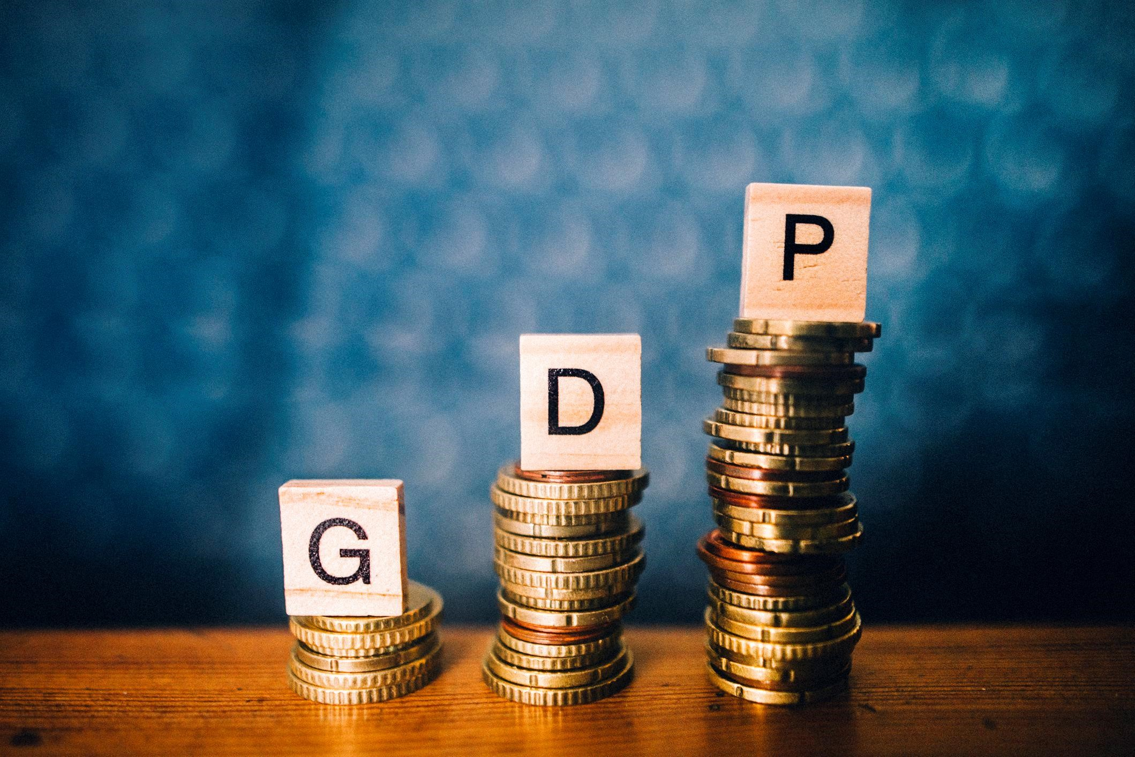

## 3. Foreign Direct Investment

• The Government of India amended the FDI policy in 2014 to increase the FDI inflow. The government increased the foreign investment upper limit from 26% to 49% in insurance sector. After the introduction of Make in India initiative, government liberalized FDI in some key sectors including Telecommunications, Agriculture, Pharmaceuticals, Civil Aviation, Space, Insurance and Pensions and Medical Devices etc.

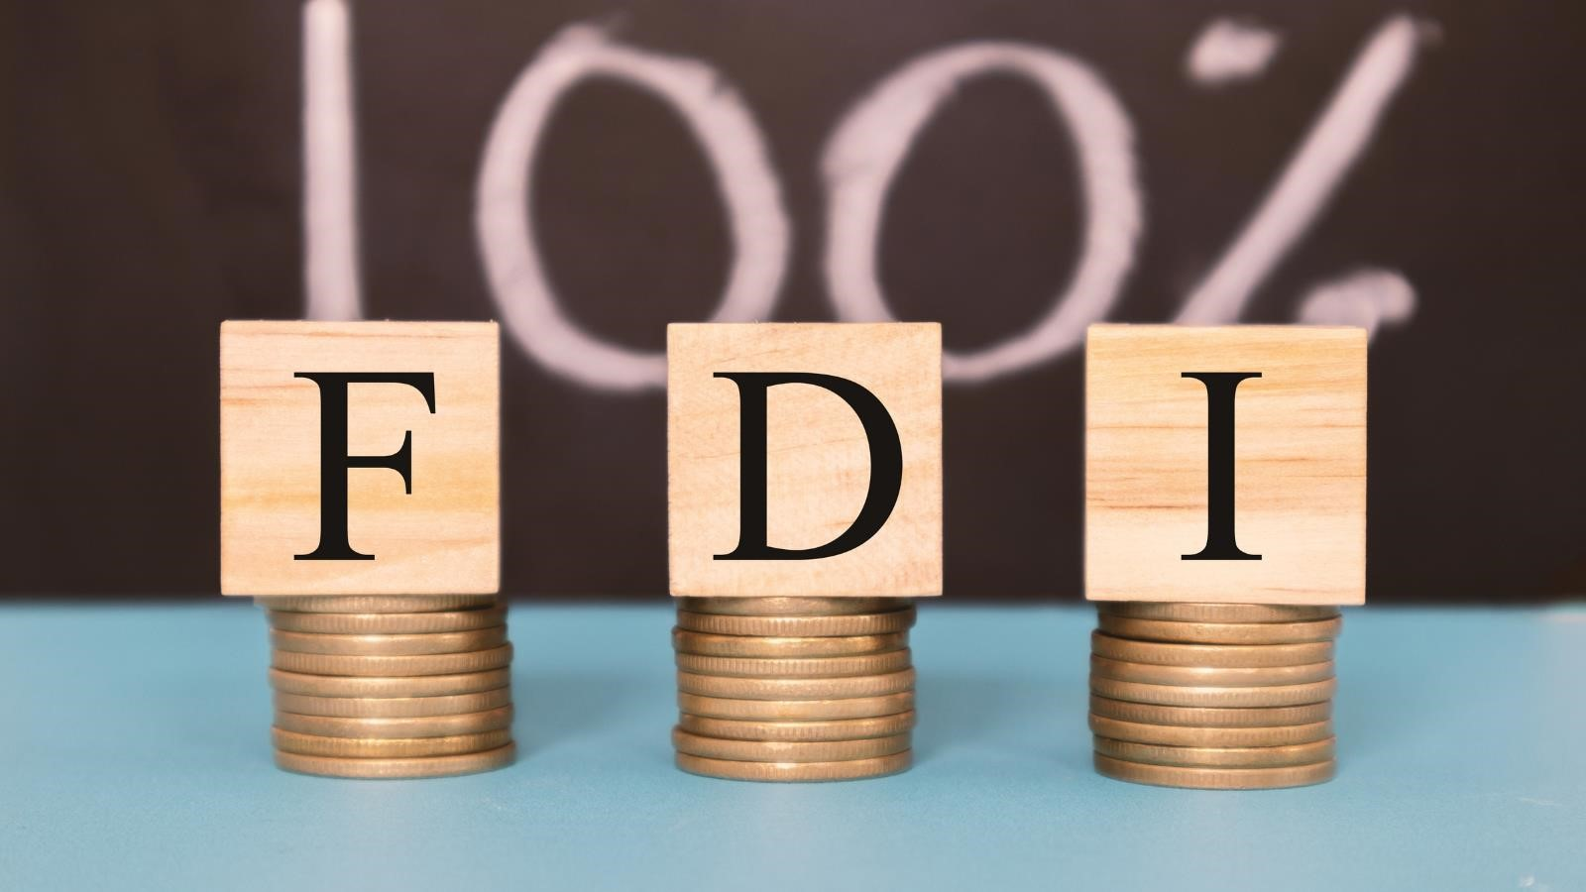

# 4. Ease of Doing Business

• India is a nation which ranked 130th on the ease of doing business scale. But with the open invitation given to the entire world to manufacture their products in India, the various restrictions opposed over the entrepreneurs will be lifted and aspiring companies from all over the world to invest in India. Thus, improving India's position on the 'Ease Of Doing Business' scale.

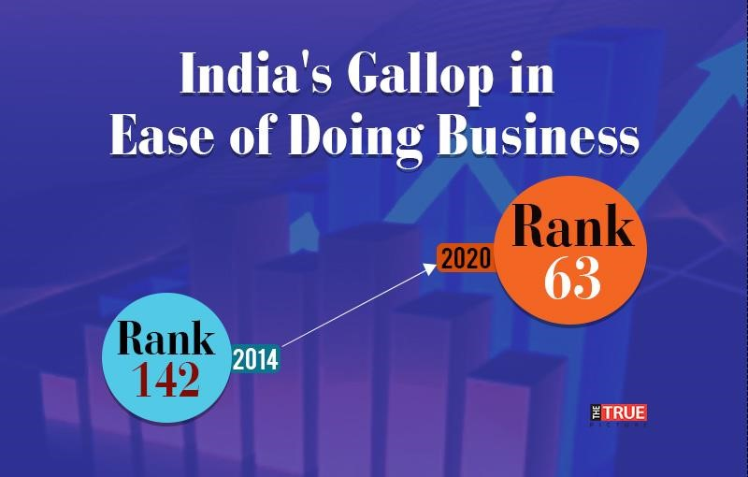

**My Suggestion For Central Govt. Which**

**Might Benefits the Indian consumers**

**Include petroleum products in GST**

❑ **How it will benefit ?**

* As demand recovered, After covid-19 the spike in global oil prices pushed petrol and diesel prices to an all-time high, leading to demand for bringing it under GST.
* Fuel prices have been hovering at record levels on account of 41 increases in its retail rates since April this year.

|  |  |  |
| --- | --- | --- |
| **Diesel & Petrol prices under GST (Assuming by Author-Prices are Noida based )** | | |
| **Price Break up per litre** | **Petrol** | **Diesel** |
| Cost price for oil companies | 47 | 49 |
| (+) OMC margins & marketing cost | 2 | 1.5 |
| Cost price for Petrol dealers | 49 | 50.5 |
| (+)Excise duty @ 18% on diesel & 28% on petrol | 13.72 | 9.09 |
| (+) Dealer commission | 3.9 | 3.5 |
| **Retail selling price under GST** | **66.62** | **63.09** |
| Retail selling price under excise/VAT | 109 | 98.42 |
| **Expected price difference** | **42.38** | **36.33** |

* Assuming that the government brings petrol prices under 12 percent GST bracket, then petrol price could come down to Rs 38.1 in Delhi while at 18 percent, petrol price will come down at 40.05 a litre. If the government pushes petrol to highest GST tax bracket of 28 percent, then it will cost Rs 43.44 per litre in the national capital.
* Similarly, if government brings diesel prices under 12 percent GST bracket, then it will be sold at Rs 36.65 in Delhi. At 18 percent GST, diesel will cost Rs 38.61 while at 28 percent GST, it will cost Rs 48.88.
* **Name- Anmol Dedha**
* **Project For- Association For Transparency, Governance & Public Grievances**
* **For role - Research (Central Govt. Schemes)**

## Reference

* <https://gstcouncil.gov.in/>
* [https://www.businessstandard.com/article/economy-](https://www.business-standard.com/article/economy-)
* [https://www.hindustantimes.com/business/case-toget-petrol-diesel-under-gst-101614898587656.html](https://www.hindustantimes.com/business/case-to-get-petrol-diesel-under-gst-101614898587656.html)
* [https://enterslice.com/learning/make-in-indiascheme-advantages-challenges-and-sectors/](https://enterslice.com/learning/make-in-india-scheme-advantages-challenges-and-sectors/)
* [https://www.businessalligators.com/advantagesdisadvantages-make-india/](https://www.businessalligators.com/advantages-disadvantages-make-india/)
* [https://www.mapsofindia.com/government-ofindia/make-in-india.html](https://www.mapsofindia.com/government-of-india/make-in-india.html)
* <https://upscbuddy.com/make-in-india/>
* <https://www.makeinindia.com/>